Outcome for the Project 1

The below screen is stating that.

* List all employees with feature of Sorting, Filtering and Pagination
* Delete employee.
* Edit Employee - Popup will get open when click on pencil Icon from gird row
* Add Employee - Popup will get open when clicking on “Add Employee” button.

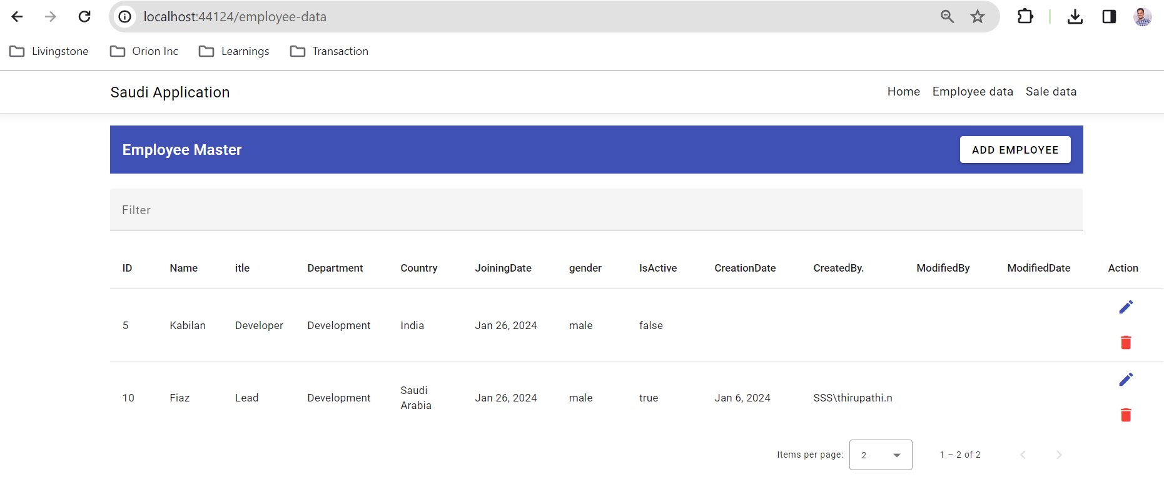

Edit Employee

Add Employee

Outcome of Project 2

The below screenshots is stating that

* List all SaletHeader + Details with feature of Sorting, Filtering and Pagination
* Delete SaleDetails
* Edit SaleDetails - Popup will get open when click on pencil Icon from gird row
* Add SaleDetails - Popup will get open when clicking on “Add Employee” button.

